**Periodic backup:**

* We need to download **“periodic build”** plugin first
* We can see **“periodic backup manager”** option in manage Jenkins once the plugin is installed.

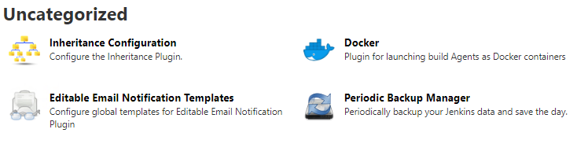

* We need to configure the below things.

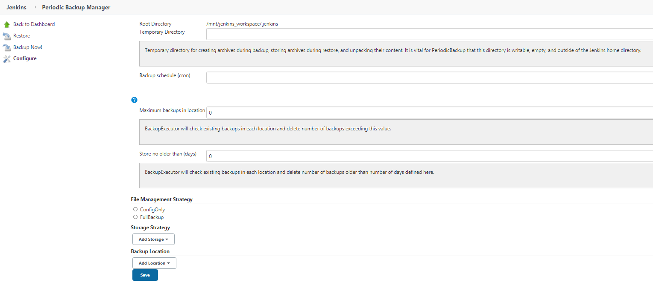

* We can schedule full back up or config only

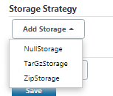

* We can also add storage strategies.

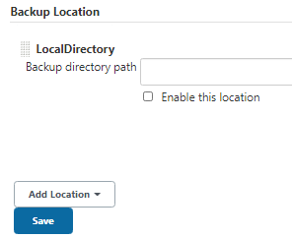

* We can also add backup location as well.